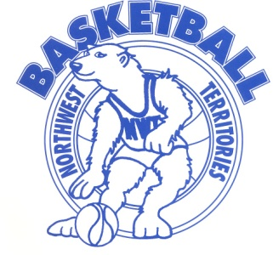

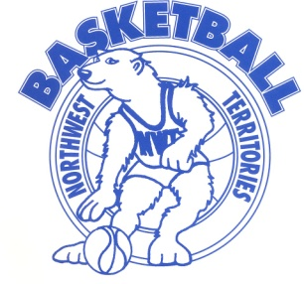
NWT Power Corp Junior CAGER REGISTRATION 2018
*Please fill out a separate form for EACH TEAM!

TEAM NAME: _____________________________
TOURNAMENT: Junior CAGER (Feb. 8th-Feb.11th)
DIVISION: ____________________________
(maximum of 4 players on each team for grade 6 divisions)
COACH(ES): _____________________________

First Name  (No Initials) | Last Name  (Please Print Clearly) | Birth date  (D/M/Y) | Mailing Address | NWT Health Care #

COACH’S SIGNATURE: _____________________________________

PRINCIPAL’S SIGNATURE: _________________________________

(As principal, I confirm that all of the above players are in good standing at my
school and are permitted to participate in the Junior Cager 2018-Tournament.)

